490/L Project Development Plan

**UPDATED FOR 491/L**

1. **Project Name**

Atlantis Project

1. **Team Members**

Gigi Lucena, Brandon Umansky, Gage Aschenbrenner, Daniel Cardenas

1. **Functionality and requirements**

Vision : The ROV (Remotely Operated Vehicle) should be able to navigate autonomously when predetermined waypoints are given. Having an unmanned ROV can cut the costs of using and maintaining it. The system can be useful to companies researching and exploring new and undiscovered underwater areas. It may also carry to on-land exploration. There may be times when it is not feasible for a human person to directly man or direct the ROV .

Link to Product Backlog : https://trello.com/b/bxpPgnDi/atlantis-project-aquabot

* 1. UI interface to input mission objective (where the ROV should go)
     1. Create mission
     2. Save mission
     3. Update mission
     4. Delete mission
     5. Load mission
     6. Start mission
     7. Route creator
  2. Definition of mission success. The user should have the ability to define a radius of success, meaning when the ROV has reached a specified distance from a waypoint, that waypoint will be treated as successfully reached/completed.
  3. Simulation of route via ROS application
  4. Utilizing LCM to communicate location, waypoints, and camera/light use
  5. System will simulate route of waypoints and communicate appropriate movement/direction to ROV
  6. The ability to correct unforeseen circumstances, such as Drift Correction. The Route Planner should be notified when position discrepancies occur, so that corrective action can be taken, and the Route Planner may plan accordingly.
  7. Visual representation of progress in live time. User should have a visual representation of the ROV’s progress and notification of success.
  8. Reuse of code for unit conversion of longitude/latitude measurements
  9. Light and Camera functionality will be assigned to each waypoint such that they are turned on or off when a waypoint is met.

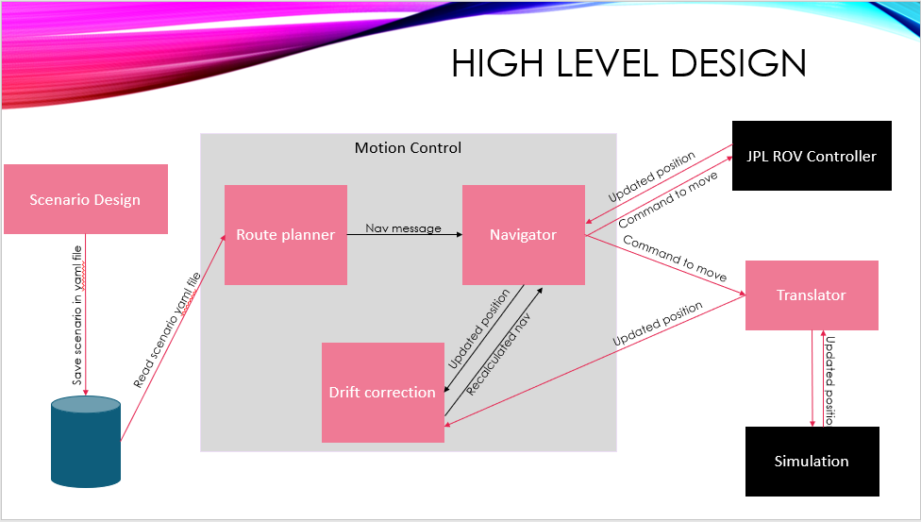

1. **Roadmap**

1st Semester

* 1. Mission Control Module to initiate missions
  2. Motion Control Module to translate missions into instructions
  3. Camera Control system to initiate recording during missions
  4. Simulated environment to represent the ROV in a body of water

2nd Semester

1. Modify system to work with ROV to replace the simulation
2. Obstacle avoidance
3. Implement A Star algorithm in python
4. Update route planner
5. Implement drift correction
6. Replace Unity
7. Create and implement yaml files
8. Convert RPM’s to direction and speed (translate to Torque)
9. **Development Methodologies**
   1. Requirements:
      1. Use Cases
   2. Design:
      1. UML (Unified Modeling Language)
   3. Implementation:
      1. Languages: Python, C#, C
   4. Verification / Validation:
      1. Test Cases
      2. Unit Testing
      3. Integration Testing
      4. Review
      5. Walkthrough
10. **Development Tools**
    1. Tools: ~~Unity~~; ROS (Robot Operating System); VirtualBox VM (Virtual Machine); Ubuntu (Linux)
       1. **UPDATE** Unity was found to be difficult and incompatible to implement so a suitable replacement has been established
    2. Libraries: LCM (Lightweight Communication and Marshalling); ROS
    3. Atom (text editor)
    4. ~~PyCharm (IDE for python)~~
       1. **UPDATE** Linux provided text editor and translator was found to be sufficient
    5. Draw.io (UML drawing)
    6. Word (Use Cases)
    7. **UPDATE** Excel (data collection and graphs)
11. **Estimated Scope**

Implement a plug and play simulation of an unmanned ROV.

* 1. Create a Mission
  2. Execute the Mission Successfully

**UDPATE**

For 2nd Semester, scope has been modified:

* 1. Translate coordinates and unit measurements to workable ROV solution
  2. Execute directional control to a satisfactory level
  3. Execute Mission parameters successfully

1. **Estimated Size**

Source Lines of Code (SLOC) ESTIMATION for 1st Semester:

|  |  |
| --- | --- |
| Module: | SLOC |
| Mission Control | 500 - 1000 |
| Simulation | 1000 - 2000 |
| Camera and Light Control | 500 - 1000 |
| Route Planner | 500 - 1000 |
| Navigator | 500 - 1000 |
| Drift Correction | 500 - 1000 |
| UI | 1000 - 1500 |
| Total | 4500 - 8500 |

Source Lines of Code (SLOC) ACTUAL for 1st Semester:

|  |  |
| --- | --- |
| Module: | SLOC |
| Mission Control | 1000 |
| Simulation | 3000 |
| Camera and Light Control | 0 |
| Route Planner | 500 |
| Navigator | 0 |
| Drift Correction | 0 |
| UI | 3000 |
| Total | 7500 |

Source Lines of Code (SLOC) Estimation for 2nd Semester:

|  |  |
| --- | --- |
| Module: | SLOC |
| Mission Control | 1000 – 1500 |
| Simulation | 4000 - 4500 |
| Camera and Light Control | 500 – 1000 **Camera and Light Control may not be implemented** |
| Route Planner | 500 - 1000 |
| Navigator | 1000 - 1500 |
| Drift Correction | 500 – 1000 **Drift correction may not be implemented** |
| UI | 3000 - 3500 |
| Total | 10500 - 14000 |

1. **Projected Risks**

|  |  |  |  |  |  |  |
| --- | --- | --- | --- | --- | --- | --- |
| # | Date | Description | Probability | Severity | Planning/Mitigation Methods | Status/Date |
| 1 | 9/16/19 | Tools used (ROS, LCM, Ubuntu/Linux) are new to some members. Each member will familiarize themselves with these tools. Time spent doing this is undetermined and may be more than planned. | High | High | Each member installs their own VM with the same version of Ubuntu. Each team member instructed to learn tools on their own. Online resources will be sought. Team members will tutor each other when able. | 9/18/2019 – Ubuntu version distributed and VM instructed  1/22/2020 – changes in member roles has necessitated familiarity with new tools. For example, one member will be working more extensively with excel, trello, and powerpoint. |
| 2 | 9/16/19 | Coordination of VirtualBox and Ubuntu installation requires that every member have same version. Each member may have their own hardware and installation issues which may delay development, since this is completed only when all members are completed. | Low | Medium | Application versions are kept up to date and used versions made clear. Team members may help with installation if necessary. | 9/23/2019 – Issues with VM and Ubuntu installation occurred. Members will install up-to-date versions from online sources. |
| 3 | 9/18/19 | Unforeseen circumstances may prevent one or more team members from being able to attend one or more lab classes. | Medium | Low | Out of school communication systems (such as WhatsApp, Slack, GitHub) will allow communication and planning to continue even when a member is not physically present. File transfers and voice communications will provide pathways for retrieving and providing information and/or data. | 9/19/19 - WhatsApp, Slack, GitHub, and Trello registered for all members. Implementation of communication apps have been successful so far.  12/9/19 – Attempts to work on project during winter break may be made more difficult as each member has various other commitments |
| 4 | 9/11/19 | Potential high cost of software tools and ROV use may hinder development and testing. | Medium | Low | Acceptable, free and open source software will be utilized. Attempts to simulate ROV movement and logic will provide a more cost-effective method of testing, rather than physical test cases. | 9/16/19 - ROS, GitHub, Ubuntu 18.04.3 LTS, Unity, and Online tutorials/manuals are being utilized at no cost. |
| 5 | 9/23/19 | Due to the project not being a full-time job for any member, other school/work responsibilities may lead to a loss of time for working on the project. Inconsistent schedules due to sporadic homework, tests, or work-related obligations may interfere with scheduling. | High | Medium | Foreseeable schedule issues (such as Exams, other Projects) can be taken into consideration when scheduling tasks during each Sprint. When a member or members anticipate a heavy workload in other classes or work during an upcoming 2-week Sprint, tasks should be assigned appropriate to their feasibility. | 9/23/19 - Work for Project Development Plan divided among members based on ability and schedule. |
| 6 | 9/13/19 | Unity may have issues with LCM and VirtualBox VM. | Medium | High | User Interface may need to be scaled back if issues arise with LCM. Other UI options will be considered as an alternative. | 1/29/20 – Unity was found to have issues with LCM which made implementation and compilation of code difficult. An alternative system for communication with ROV, such as using yaml files, is being worked on |
| 7 | 9/23/19 | Time of communication to modules may be critical to mission success. If processes take too long to provide navigation to the ROV, the route planner may become less effective or error prone. | Medium | High | Testing should provide a better scope of process timing, as well as identify any possible delays or errors. | 1/29/20 – Due to changes in mission control, and no longer using UNITY, testing will be done on executing yaml to evaluate their effects on performance |
| 8  **  new | 2/5/20 | Overestimation of project goals. This can lead to an overabundance of tasks that may not be feasible for manageable. | High | High | Scale back on unworked tasks. Expand on existing tasks that show potential for improvement. | 4/1/20 – Project goals scaled back due to COVID-19 |
| 9  **  new | 2/5/20 | Adding unnecessary features. This can take away valuable time that could otherwise be spend on important features or requirements. | Low | Medium | Evaluate benefits of work done with performance achieved. | 4/1/20 – Unnecessary features and those reliant on physical testing abandoned |
| 10  **  new | 2/5/20 | Academic or conceptual limitations, such as inability to work with advanced mathematics or concepts without a person of expertise on the subject. Without expertise or experience on certain subjects it may limit our approach or scope. | Medium | Medium | Evaluate members capabilities and adjust tasks to accommodate their knowledge and/or experience. | 4/22/20 – A-Star algorithm scaled back due to time limitations and complexity |
| 11 ** new | 4/1/20 | COVID-19 lockdown and campus closure may introduce issues in communication and task cooperation. | High | High | Maintain sprint meetings using Zoom, an application for online video conferencing. Keep PAL updated online. Rely on WhatsApp for mediating communications. | 4/22/20 – Scaled back on tasks and deliverables. Functional requirements adjusted as needed to a pure simulation testing. |
| 12 ** new | 4/1/20 | COVID-19 may introduce issues with physical ROV | High | High | Rely on Simulation if physical ROV not accessible. Make a video demo of simulation instead of physical demonstration. | 4/7/20 – Physical ROV confirmed to not be accessible. Developing a demo of simulation instead. Using team members existing computer technology and software to produce and edit video demonstration. |

1. **PAL description**

Our Project Assessment Library will contain in a Google drive will contain our working Project Development Plan, link to Trello (Project planning, backlog, tasks), link to GitHub (code), link to Slack (Communication and file transfer application).

Link to PAL : <https://drive.google.com/drive/folders/1D58s5rOhGbV4GcWEc2uUwAG5J9ozqpOS>

* This PAL contains folders containing Documentation, Mission Control Executables, OVA’s, Papers, Presentations, and Sprint Slides

1. **Project Progress**

Project progress will be tracked using Trello, an online, browser-based tool using boards, lists, and cards to enable organization and prioritization of our project’s parts. Trello will help maintain the backlog by organizing the tasks based on To-Do, In-Progress, and Completed statuses. Tasks can by assigned to individual or multiple members. All members have access to and may modify the contents of Trello at any time. Tasks may be added or removed if necessary.

**UPDATE**

Project Management data (such as effort hours and schedule planning) will also be held in excel spreadsheets locally by the project manager.

1. **Process description**

Team Roles:

|  |  |
| --- | --- |
| Name | Role |
| Gage Aschenbrenner | Scrum Master |
| Brandon Umansky | UX Developer |
| Daniel Cardenas | ~~Development Engineer~~  Project Manager |
| Gigi Lucena | Project Lead |

Planning:

Planning will be done from the top-down. We developed an abstract, high level design for our first sprint. Each subsequent sprint will consist of selecting a module of the abstract design and making it concrete.

After a module is broken down into its main components (inputs, outputs and UI requirements) we will plan and assign for a member of the team to implement all or some of these components.

Backlog:

The product backlog will be maintained by ~~Gage Aschenbrenner~~ Daniel Cardenas using Trello.

Releases:

Every two weeks an executable prototype or module will be demonstrated to the Product Owner.